**Name**: Mohamed Khaled Helmy Abdelmohsen

**ID: 695**

**Group: 6**

**Section: 31**

**Topic**: Internet Of Things

**Application Brief**: I chose this topic because its applications are the most used in the world

**GitHub-Link:**

**GitHub-Page(Published Website):**

**Screenshots**:

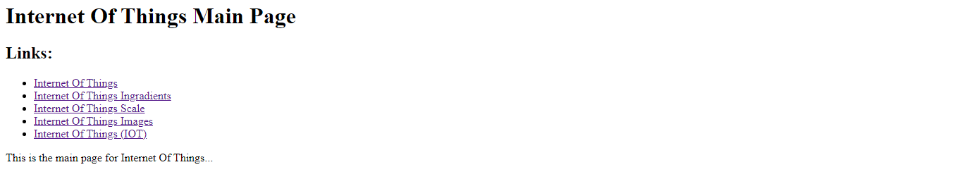

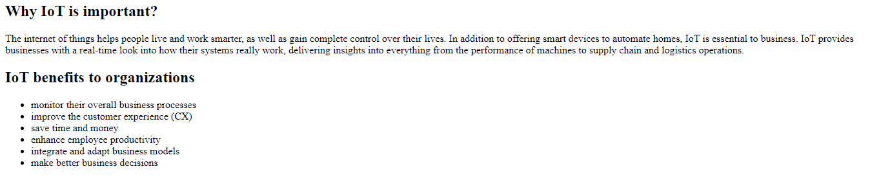

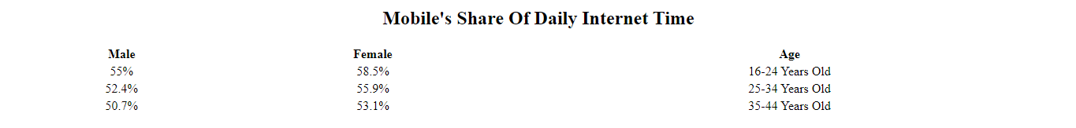

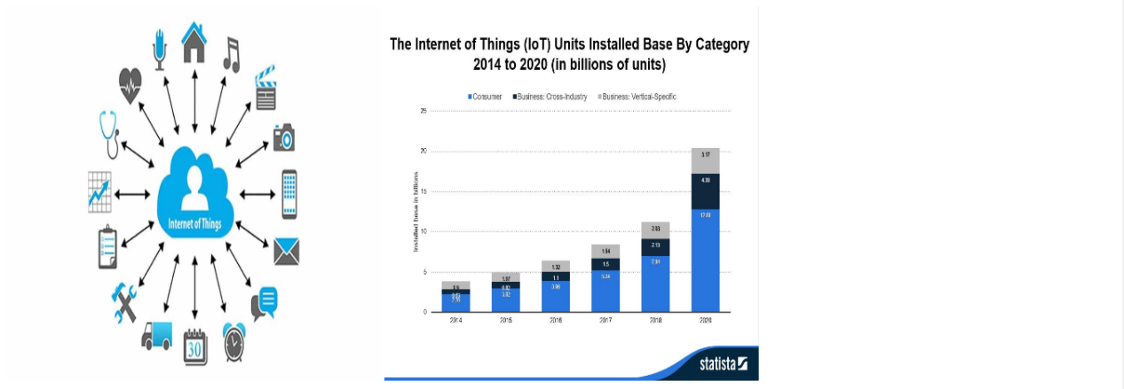

**Source Code**:

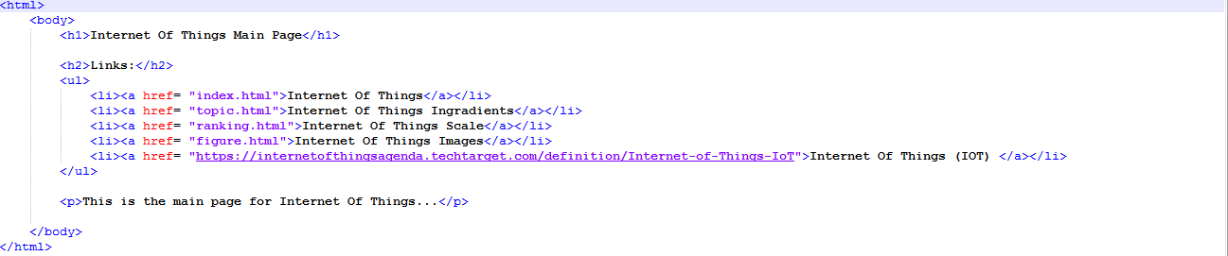

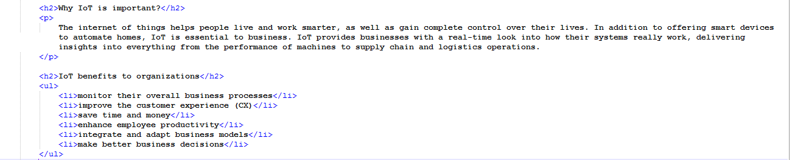

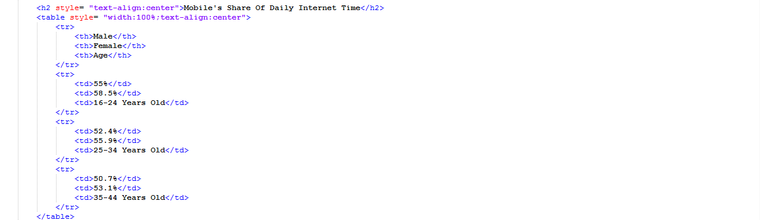

8